**Lab 1**

Michael Peterson

1)

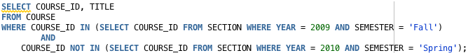

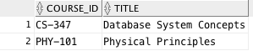

My initial Plan:

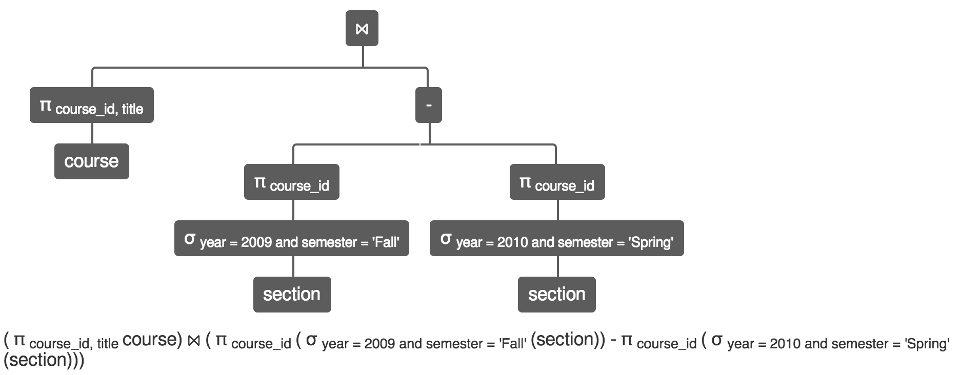

Oracle plan

Macintosh HD:Users:michael:Desktop:Spring 2017:CSCD 427:github:Lab_1:Prob1_Oracle.pdf

Updated plan

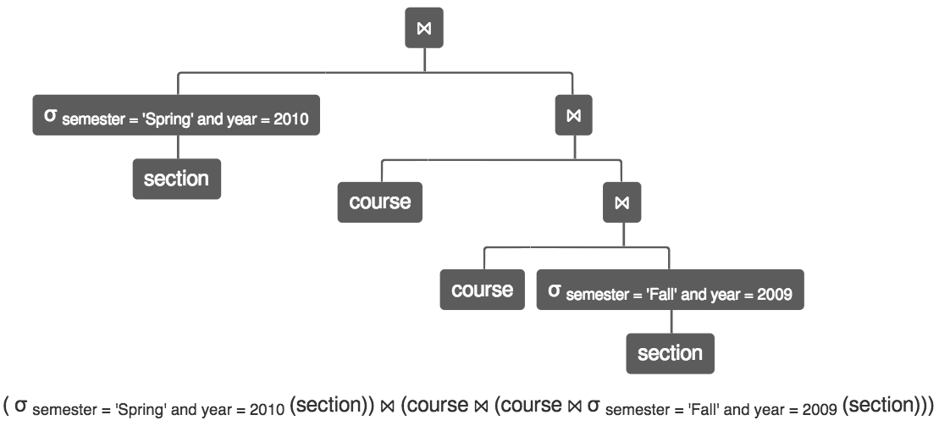

2)

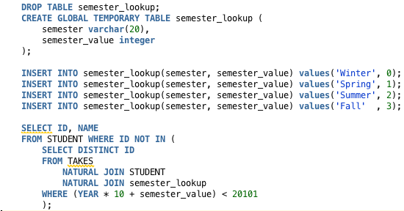

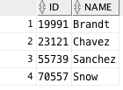

3)

Macintosh HD:Users:michael:Desktop:Screen Shot 2017-05-12 at 4.11.03 PM.png

Macintosh HD:Users:michael:Desktop:Screen Shot 2017-05-12 at 4.21.13 PM.png

4)

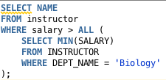

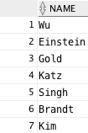

5)

Macintosh HD:Users:michael:Desktop:Screen Shot 2017-05-14 at 6.04.15 PM.png

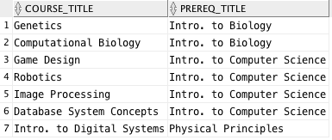

6)

